BIDDENDEN BOWLS CLUB
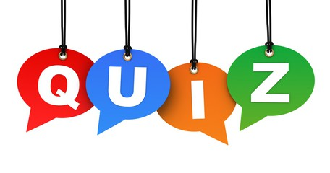
SATURDAY 30th NOVEMBER 2024

7PM PROMPT

BIDDENDEN NEW VILLAGE HALL

£5 per person -tables of 6 people
Bring your own drinks and nibbles

To book a table please contact
jeannetteoatway@btinternet.com or text her on 07890818490

